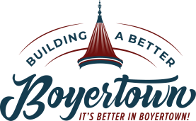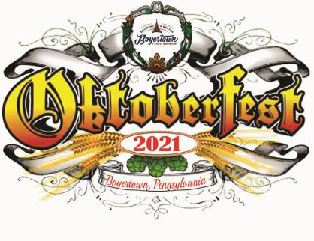

Event Overview
What: The 14th Annual Oktoberfest is a fundraising event for Building a Better Boyertown. Participants will enjoy a German and fall-themed event, including beer, delicious food, music and entertainment, and a variety of craft vendors. Each year this event draws approximately 5,000-8,000 attendees and continues to grow in popularity.
Where: Town Center Parking Lot, Boyertown PA. Parking lot behind the first block of E. Philadelphia Ave.
When: Friday, September 17th – 5:00-9:00pm & Saturday, September 18th – 11:00am-9:00pm (Rain date: Sunday, September 19th)

Why: Why is Oktoberfest in September? The German Oktoberfest in Munich, Germany starts on the same weekend. The original Oktoberfest began in 1810 as a wedding celebration for the crown prince of Bavaria.

Sponsor Commitment

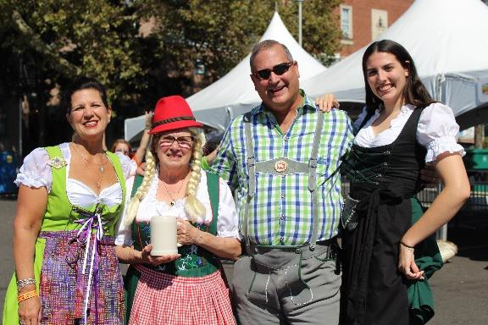
Please complete the following:

Please check the applicable sponsor level -
- Platinum Sponsor - $2,500
- Gold Sponsor - $1,000

Silver Sponsor - $500
- Bronze Sponsor - $250

Keg Sponsor - $100

Contact Name:

Business/Organization Name:

Address:

Email Address: Phone Number:

Please make checks payable to Building a Better Boyertown and return this form to:

Building a Better Boyertown, Attn: Oktoberfest 3 E. Philadelphia Ave., Boyertown, PA 19512

For additional information, please visit www.buildingabetterboyertown.org or email events@boyertownpa.org.

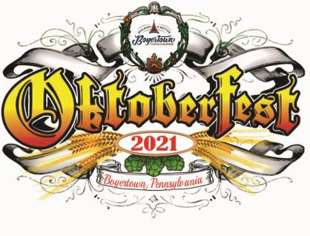

Sponsorship Levels

Platinum Sponsor - $2,500
Representation of your business or organization before and during the event including: sponsor interview spotlight on BaBB website and social media; recognition in event press release; opportunity to have your organization bartend (see notes below) at the event during allotted time slots; public address announcements throughout the day of the event; event sponsor board listing with logo; and recognition on BaBB website and social media with following of almost 8,000.

Gold Sponsor - $1,000
Representation of your business or organization before and during the event including: recognition in event press release; opportunity to have your organization bartend (see notes below) at the event during allotted time slots; public address announcements throughout the day of the event; event sponsor board listing with logo; and recognition on BaBB website and social media with following of almost 8,000.

Silver Sponsor - $500
Representation of your business or organization before and during the event including: opportunity to have your organization bartend (see notes below) at the event during allotted time slots; public address announcements throughout the day of the event; event sponsor board listing with logo; and recognition on BaBB website and social media with following of almost 8,000.

Bronze Sponsor - $250
Representation of your business or organization before and during the event including: event sponsor board listing with logo and recognition on BaBB website and social media with following of almost 8,000.

Keg Sponsor - $100
Representation of your business or organization before and during the event including: event sponsor board listing and recognition on BaBB website and social media with following of almost 8,000.

Bartending Information: Bartending time slots are given on a first-come, first-serve basis, based on date of sponsorship receipt and sponsorship level. Every effort will be made to accommodate sponsors wishing to bartend. To bartend as a group, you will need to have 6-10 people, depending on the time of day. We can have smaller groups, but they may be combined with other sponsors to ensure the bar is adequately staffed.

To ensure your business receives maximum exposure, please confirm your sponsorship by August 1st.

